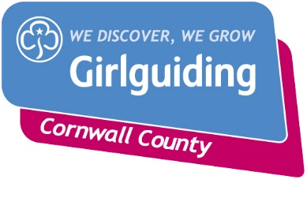Gold Awards

How the process works……

Rainbow, Brownie, Guide or Ranger has completed the Gold Award for her section.

Relevant Section Advisor to notify the County Badge Secretary to issue the badge and certificate to District Commissioner for her to present at the appropriate time/event.

Unit leader along with the young person to complete the Gold Award form and submit the form to the relevant section adviser via email

Contact emails

Rainbow Adviser [rainbows@girlguidingcornwall.org.uk](mailto:rainbows@girlguidingcornwall.org.uk)

Brownie Adviser [brownies@girlguidingcornwall.org.uk](mailto:brownies@girlguidingcornwall.org.uk)

Guide Adviser [guides@girlguidingcornwall.org.uk](mailto:guides@girlguidingcornwall.org.uk)

Ranger Adviser [rangers@girlguidingcornwall.org.uk](mailto:rangers@girlguidingcornwall.org.uk)