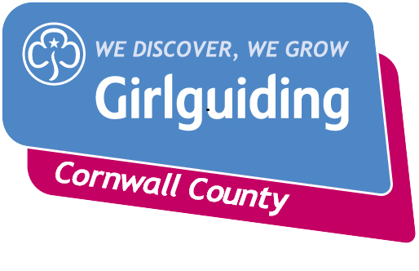
Badge Order Form to be sent to the County Badge Secretary.
Orders will only be sent on receipt of order form and cheque
Date:

District Name:
Leader Name:
Phone Number:
Email address:

Postal address for badge order:

Section | Quantity | Description | Cost each | Total cost
SUB TOTAL

POSTAGE AND PACKING (PLEASE SEE LIST FOR COST)
TOTAL COST (CHEQUES MADE PAYABLE TO CORNWALL GUIDES BADGE ACCOUNT)

If you require more room please continue your order on a separate piece of paper.

Postage and packing:
1-20 badges please add £1.00
21-40 badges please add £1.50
41- 60 badges please add £2.00
Over 61 badges please add £2.50

All orders and any queries please contact the County Badge secretary : Email badges@girlguidingcornwall.org.uk
Instructions and guidelines for badge orders
- Orders can come from either:
  - a unit leader or
  - a district badge secretary or a district representative.
- Orders to be sent to the county badge secretary ideally between the 1st and 10th of each month using the order form but will be accepted at other times of the month.
- All orders must be accompanied by a district/unit cheque. No personal cheques will be accepted.
- Please take care to order the correct badges for the correct section. If you are not sure - please email to check.

