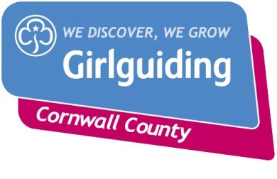
County Training Day via Zoom
Saturday 3rd October 2020
Things are a little different this year!
New approach for training for the county team
It’s free. Spaces are limited!

Title of Session | Session to cover:
Financial Matters during Covid 19  AM session | - Annual subscriptions  - What budgeting/fundraising do you need to do?  10 places available
Programme Updates over Covid  AM and PM session | - Programme updates since Covid, including badges, hours etc  - GO recording for the girls  A time to reflect and take stock what and where your unit is!  10 places available 10 places available PM
Social distancing activities in the unit place or via zoom (BOGOF)  AM and PM session | - Leaders to bring ideas and share them (bring one and get one free)  - Principles of social distancing and guidance from HQ for indoor and outdoor meetings including risk assessments  10 places available AM 10 places available PM
Commissioner Session  PM session | - A time to reflect and take stock of your District/Division  10 places available
Getting your unit back up and running  PM Session | - Virtual Team work with unit leaders  - Key things to think about to enable you to get back and take that leap to run.  10 places available

Sessions will only be 1-hour long. Please only book 1 session. There are only 10 places available per session. If there is another session you wish to book on to please add this to the Booking Form and we will try and accommodate you.
If this is successful the Learning and Development Team will run the same sessions above, at other times during the term. If sessions fill quickly we will hold a waiting list so we can gather and understand the numbers etc.
Please complete the Booking Form and return it by 26th September 2020.

