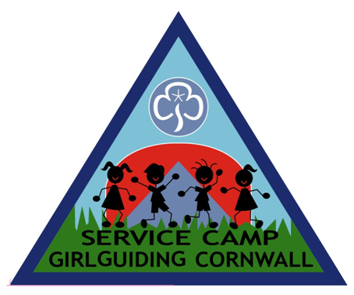**Girlguiding Cornwall’s**

**Service Camp 2020**

Under the Sea

At Brunel School, Callington Road, SALTASH, PL12 6DX

Sunday 16th August 2pm until Saturday 22nd August 11am

INFORMATION

Service Camp is a unique camp that Girlguiding Cornwall is very proud to run each summer. It is packed full of the day trips and all the activities we love most in Guiding.

**The “Little People”** - We will be offering 24 “little people” a break from their everyday lives. These children aged 7-11 are carefully chosen by Cornwall’s Social Services and are selected for a variety of reasons - but the one thing they have in common is the need for a holiday.

**The “Big People”** – This could be you! We are looking for 24 “big people” aged 14-25, male and female to help us make this an unforgettable holiday for every child. Each “big person” works 1:1 with their “little person” for the week. As a big person, you join in all activities with your little person. You encourage them to relax and take part, to work as a team and to make sure they brush their teeth, put on sun screen lotion and to drink plenty of water, from the time they wake up until they fall back to sleep!

“In all my years of volunteering, I have never done anything as rewarding as spending a week with a little person on Service Camp.”

**“Group Leaders”** – 4 ‘little people’ and 4 ‘big people’ make up a group; one member of each group will have previous experience, they will be ready to help and support you.

**Adult Team** – There are many adults around to help. They come from a range of backgrounds and have a variety of experience and knowledge. They are here to help and also join in the fun.

“Camp is really tiring, but I have made so many friends and have so many memories, I would never miss it — I love seeing the smiles on the children’s faces”

**Activities -** This camp is the only holiday many of these children will have so we pack it full of activities - It’s a Knock Out, challenges, campfire, day trip to woodlands, the beach and swimming. We appreciate the time you have given up and are sure you will enjoy these too.

**Accommodation** – We have use of the school kitchen, canteen and toilets, this is perfect for eating, washing and activities. Overnight we camp in the secure school field; we also have use of the school playgrounds and play equipment.

To make Service Camp successful, we need the help of some super people: Cornwall’s Senior Section, DofE participants and Cornwall Explorer Scouts. For over 40 years this camp has offered a much needed holiday to children in Cornwall, who aren’t as lucky as ourselves. It is a fun way to meet new people and help your community by doing something amazing!

So come and join our excited and enthusiastic team this year so that, together, we will build experiences and memories for all.

If you would like any more information please contact Cheryl on 07429499711 or

[servicecamp@girlguidingcornwall.org.uk](mailto:servicecamp@girlguidingcornwall.org.uk)

Don’t forget to find us on facebook – ‘Cornwall Service Camp’

**Girlguiding Cornwall’s**

**Service Camp 2020**

Under the Sea

At Brunel School, Callington Road, SALTASH, PL12 6DX

Sunday 16th August 2pm until Saturday 22nd August 11am

|  |  |
| --- | --- |
| **COVID-19 update**  This year the children will need this week break more than ever before! We are therefore continuing to monitor the current situation and unpredictable timings. We hope to go ahead as planned, with a few changes in August as long as it is safe and we are allowed to. If it cannot happen, we will look at running something similar in October half term. Please indicate which dates you would be available. We will update you as soon as a decision can be made. | |
| Sunday 16th August 2pm until Saturday 22nd August 11am | Sunday 25th October 2pm until Saturday 31st October 11am |

Personal Information

|  |  |  |  |  |
| --- | --- | --- | --- | --- |
| Name: | | | | Unit: |
| DOB: | Please include a photo of yourself, | | | If you will be over 18 years old, you will need a DBS through Girlguiding Cornwall, this is free and we will help with this. |
| Tel: | | | Guiding Number: (if applicable) | |
| Email Address: | | | | |
| Ranger / Young Leader / Adult Leader / Explorer/ Network / DofE (Please circle as appropriate) | | | | |
| Any physical, medical or mental health information that will be useful for us to know | | | | |
| Any allergies or special dietary needs?  Vegetarian? Yes/No | | | | |
| Service camp can be used towards your Gold DofE or Queen’s Guide residential.  Would you like to use it - No / QG / DofE / QS | | | | |
| Any Hobbies or Interests | | It is important that Big people sleep near their little person so they have someone familiar in the night if needed. If you would like to share a small 3man tent with up to **one** other, please let us know who you would like to share with: | | |
| 3 words that describe you | | | | |
| Please circle the age and sex of the child who you think you would match best  (we will aim to match this if and where possible) Boy Girl 7-9 9-11 | | | | |
| Please indicate if you will need to arrive late, pick up exam results or leave early:  (we will aim to cover this but it is not always very easy) | | | | |

**Payment;**

Once the date has been confirm, we will confirm the 24 spaces and then arrange payments.

The coast of camp £50 (Funding may be available from Units, Districts, Divisions and County)

An optional service camp polo shirt is available at an extra £12 or hoodie at £15

|  |  |
| --- | --- |
| Signed:  (by parent or guardian, if under 18) | Date |

Please register your interest by returning this form by email to [servicecamp@girlguidingcornwall.org.uk](mailto:servicecamp@girlguidingcornwall.org.uk) before May 31st.

We will select our 24 successful big people once we can confirm the date and then arrange payments