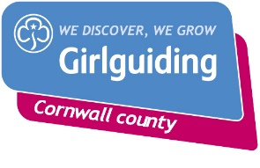
STEM Resources available to borrow from Cornwall County

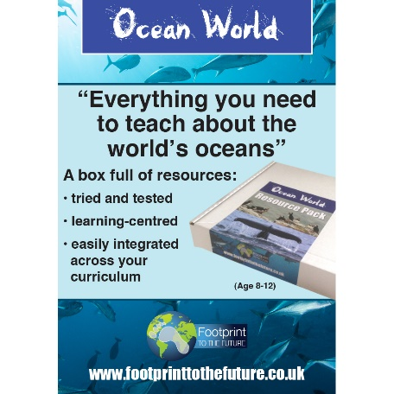
This resource contains lots of Powerpoints and short films which you could use to introduce activities based on the ocean. There are lots of activity cards such as bingo available as well. The resources are available to borrow on a memory stick but you would need access to a laptop during your meeting to be able to show the films and Powerpoints to your girls.

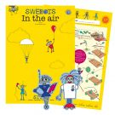
The Swebots are a South West England resource with lots of activities based on air and water. Great for a themed evening or maybe to use at a pack holiday or camp.
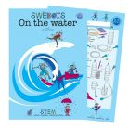

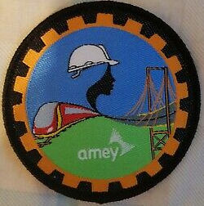
We also have a copy of the Amey Guiding Into Engineering Badge Pack plus badges.

There are small sets of:
Jumbo magnifiers, Bug collectors, Magnets plus iron filings, Mirrors and a small triangular prism

If you would like to borrow these resources or require any help with STEM activities then please contact Sally Berne at stem@girlguidingcornwall.org.uk

